First install the App code and Driver, like ST.

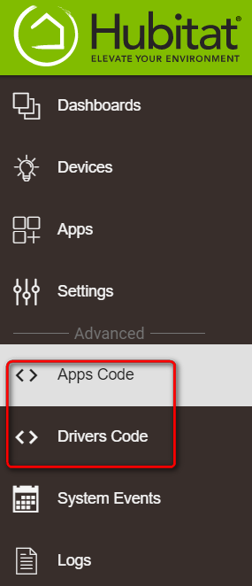

**App Code**

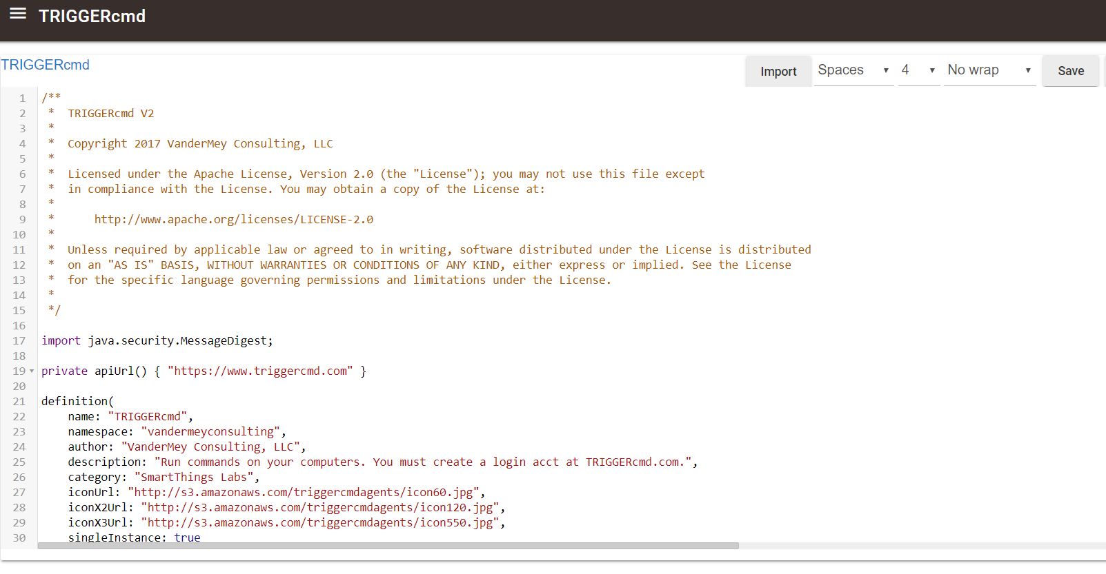

**Driver**

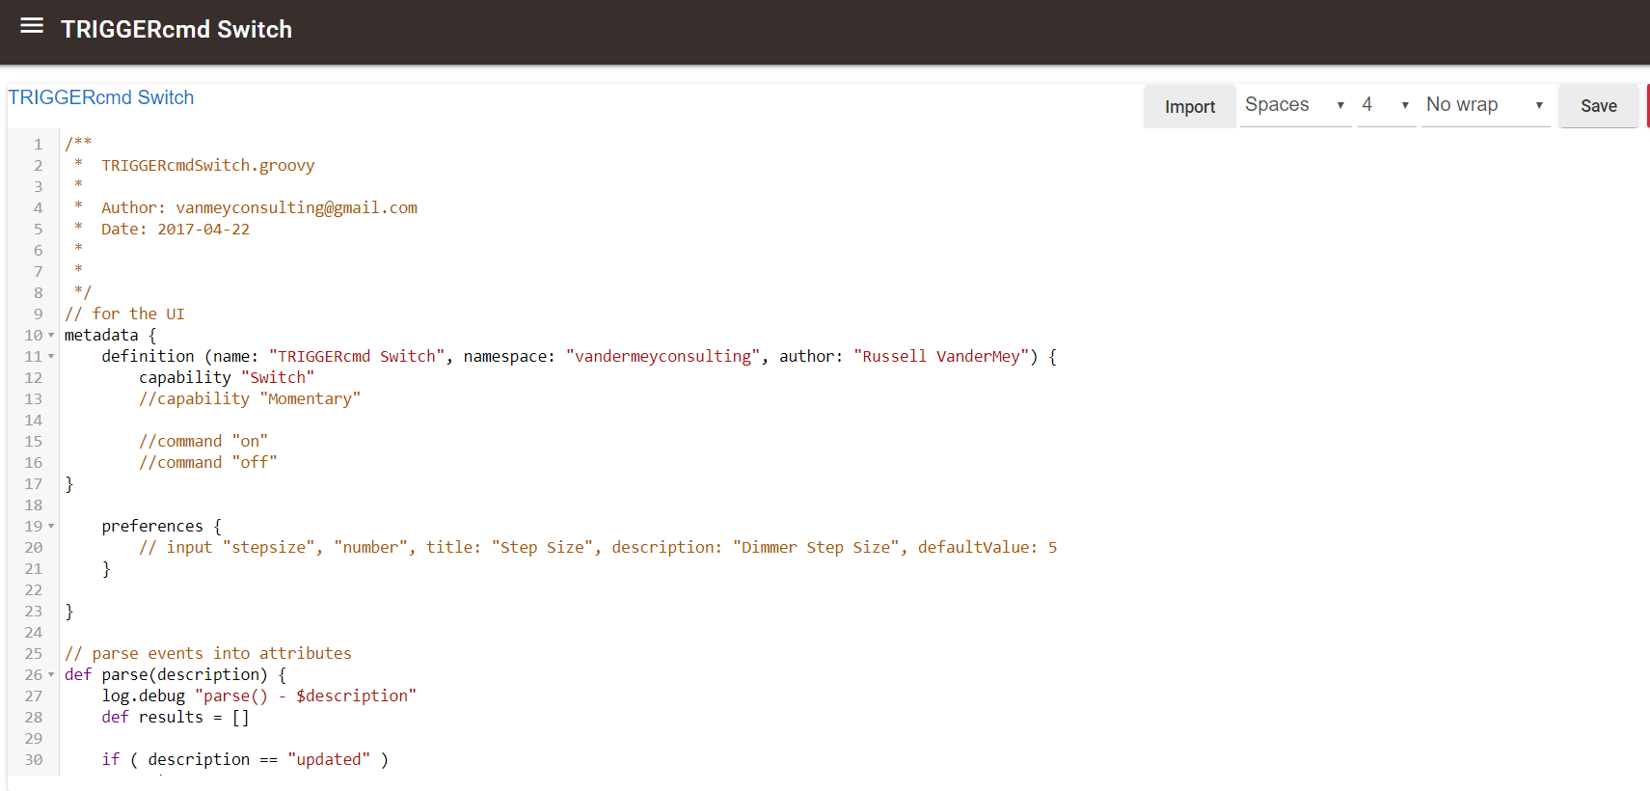

You can also import the code via the Raw Guthub URL too, which is easier. Once I have the Github URL, I’ll add this so users can simply hit “Import” should there be any new updates.

**Install the App.**

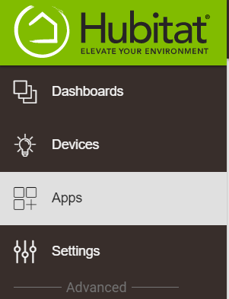

**Add New App**

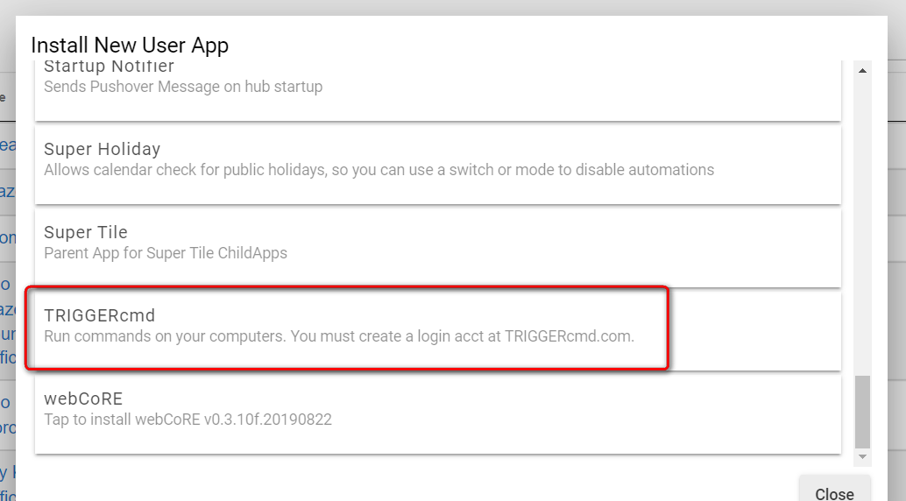

**Set the options**

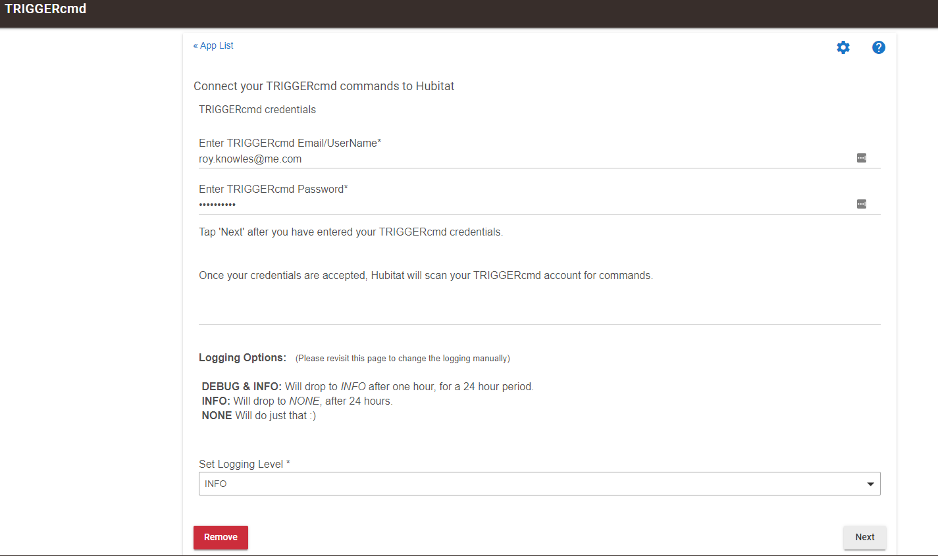

**Then ‘Next’**

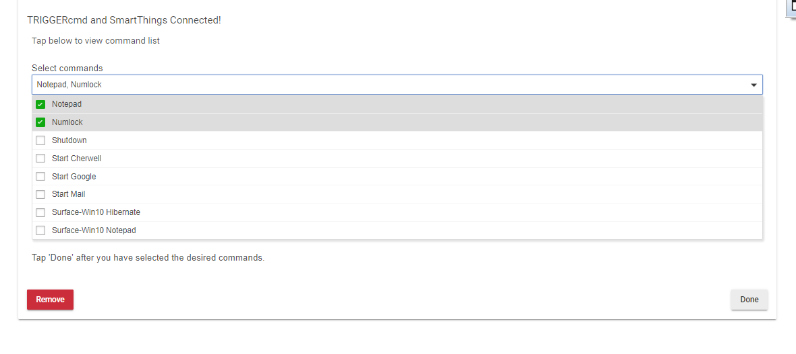

**Choose the devices and hit Done**

The devices are then installed.

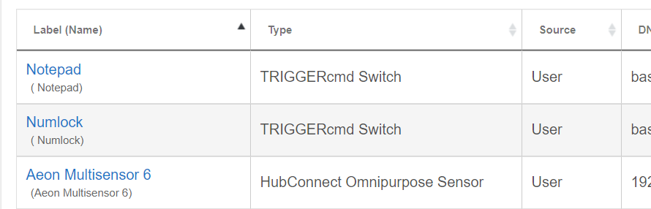

To trigger, simply Turn the switch on. 😊

